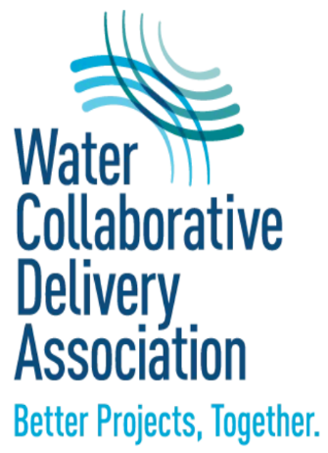

**The Water Design-Build Improvement Act of 2022**

H.R. 7119, The Water Design-Build Improvement Act of 2022, would authorize collaborative delivery methods as options for water and wastewater-related infrastructure projects. The legislation would amend the Water Infrastructure Finance and Innovation Act (WIFIA) of 2014 to “authorize the selection of eligible projects to be carried out using collaborative delivery methods.” H.R. 7119 was introduced by Rep. Sharice Davids (D-KS) and Rep. Nancy Mace (R-SC) in March 2022.

**What is collaborative delivery?**

Collaborative delivery – often referred to as design-build – is an approach to procuring and delivering capital projects that involve close collaboration among the owner, designer, and builder. This system streamlines projects allowing for quicker uptake of project implementation than the traditional design-bid-build method. In design-bid-build, a project owner contracts the design of the facility with one company and then bids out construction of the design with another company. In design-build/collaborative delivery, an owner contracts with one firm to design and construct the project. Benefits of using collaborative delivery include significant cost savings, faster project delivery, and staffing, and reduced risk.

**What would the legislation achieve?**

H.R. 7119 clarifies Congressional intent that the EPA may award WIFIA funds to applicant projects that plan to use collaborative-delivery methods. The bill also directs the EPA to carry out a study of the use of collaborative-delivery methods on federally funded water and wastewater infrastructure projects.

**For More Information:**

Matt Pearce [mpearce@vennstrategies.com](mailto:mpearce@vennstrategies.com)

Doug MacGillivray [dmacgillivray@vennstrategies.com](mailto:dmacgillivray@vennstrategies.com)

<https://waterdesignbuild.com/>